GSA Advantage

The GSA Advantage web site is available by clicking on the GSA button

Below is what you should see. This site is great for researching GSA items of supply and checking the status of your GSA requisitions. This site may also be used for requisitioning if you are authorized to purchase and have a Government Purchase Card.

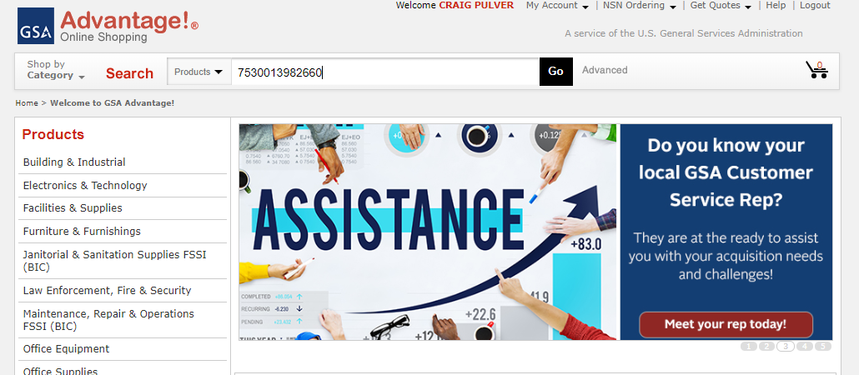

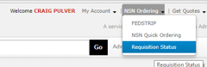
Checking status of GSA requisitions

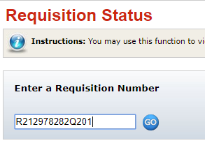
In the upper right hand portion of the GSA home page, look for Requisition Status under NSN Ordering. Click on it and you will get a screen with a window to enter a requisition number. On your material outstanding report select a GSA document number. The below example is what should be returned, if the requisition went to GSA. Items on your material outstanding file listed with a Source of Supply (SOS) of GSA may be incorrectly labeled and may be DLA. This would return a no record response.

One problem when ordering material from GSA is there may be a minimum order quantity. Even though FEDLOG has it listed with a unit of issue of each, when you go to the GSA Advantage web site, you may find there is a minimum order quantity. Search for NIIN 013892660

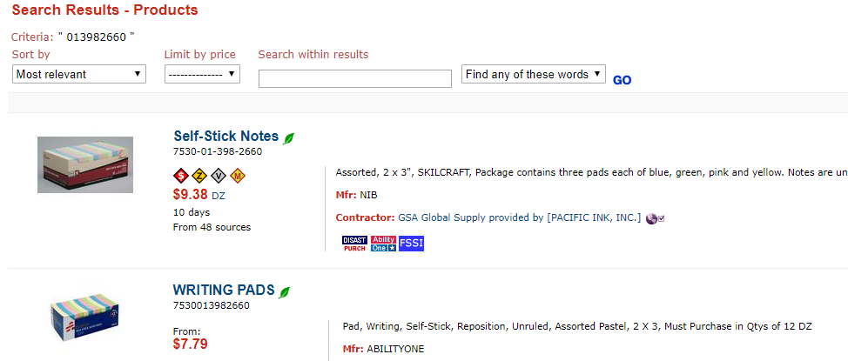

Since you are ordering via MILSTRIP, select a source in the lower left hand corner of the web page to GSA Global Supply Items and the one source is returned. Click on the nomenclature to see if there are any minimum order quantities or dollar value. In the case of the self-stick notes, the price is $9.38 and the minimum order value is $28.75.

If you don’t order the minimum, GSA will cancel your requisition with C8 status.

If you try to order a NIIN that GSA may manage but currently doesn’t have a contract on, you will also get C8 status. You could write an email to ncsccustomer.service@gsa.gov with the cancelled document number and NSN and ask them to put it on contract. This could be a 75-day lead time. Most likely an unacceptable situation for most and you may want to do an open purchase.

