Commercial and Government Entity (CAGE)



Click on CAGE Search and enter a CAGE Code
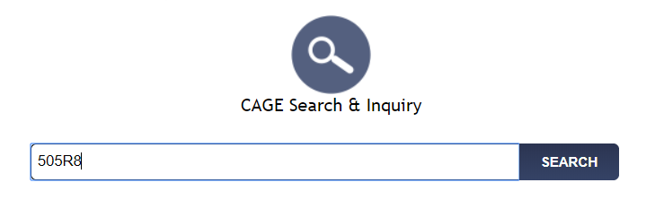
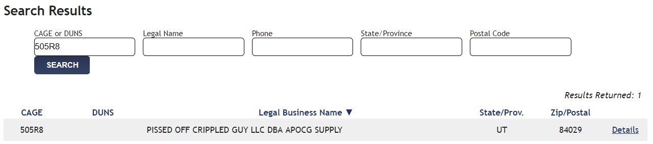

Click on Search to get the detailed CAGE information.

Now click on details for the below

