DLA WebFLIS

This system is managed by the DLA’s Information Services, in Battle Creek, MI, and has over 8 million items of supply (NSNs) cataloged. To access the FLIS site you need to register with the AMPS system first at WWW.AMPS.DLA.MIL. FLIS provides information on supplies and parts in the Federal inventory. This information includes the National Stock Number (NSN), item name, Source of Supply (SOS), part numbers, freight data, hazardous material indicators, substitute parts, management data (such as acquisition advice code and price), and physical and performance characteristics. Many of you are familiar with FEDLOG, this is also a product created from FLIS data. All commercial, government programs and systems which have technical information get it from FLIS. This is the most up to date general purpose system for technical data.

Once you are logged into WebFLIS, the below page is displayed. This screen allows you to search by NIIN or part number and also CAGE.

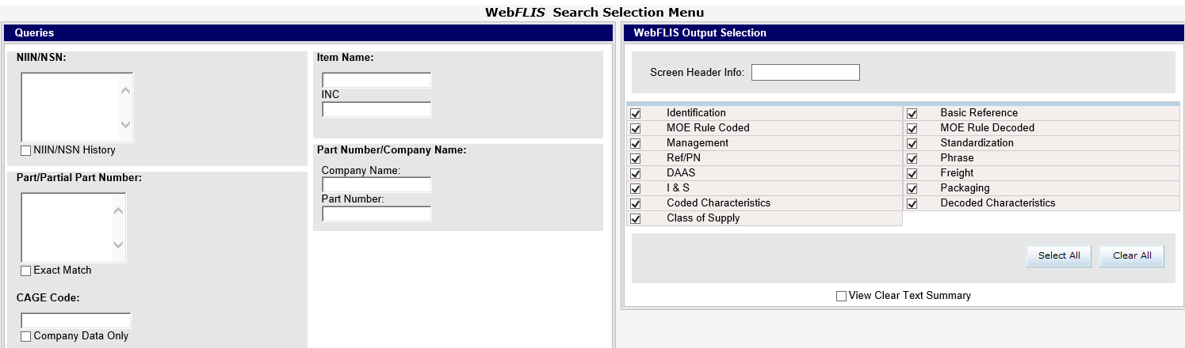

Enter a NIIN, or if you don’t have one, use 009092483. Notice on the top right, you can select additional Output Selection Views. Now click on “Search”.

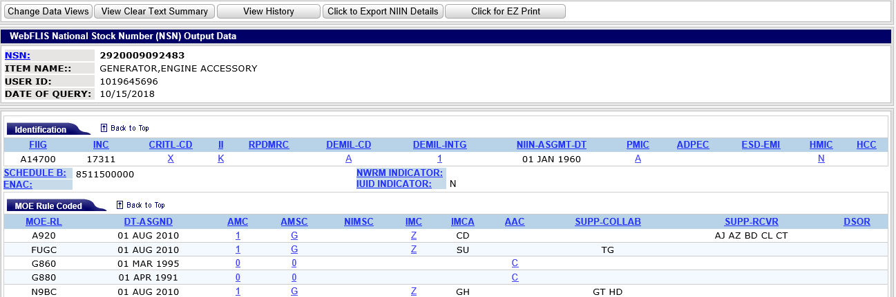

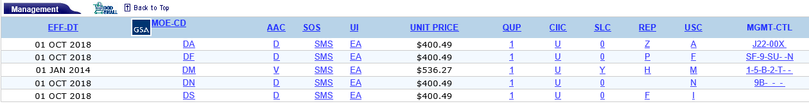

By clicking on the blue and underlined Acquisition Advice Code (AAC) of “D”, another window will pop up to give the definition. AACs can vary for each Service so make sure you are looking at the right line. Navy is DN.

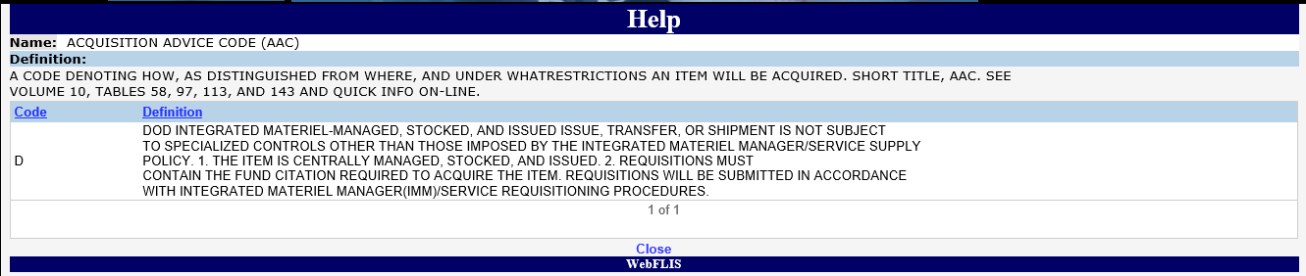

Let’s look at all the Part Numbers and CAGE Codes of the manufacturers which have manufactured 00-909-2483. If you want to call someone for availability of assets or have a technical question, all you would have to do is click on any of the CAGE Codes (CAGE-CD) or use BINCS system. BINCS has addresses and POC telephone numbers for all vendors registered to do business with the Government. This site is managed by DLIS in Battle Creek, MI. They are in charge of managing all vendor information. So if you were to click on the CAGE Code 24975 for PN A0013002AC, you would get the following information and as you see, on the next page, the POC is Barbara Musty. BINCS is also available in LogTool.

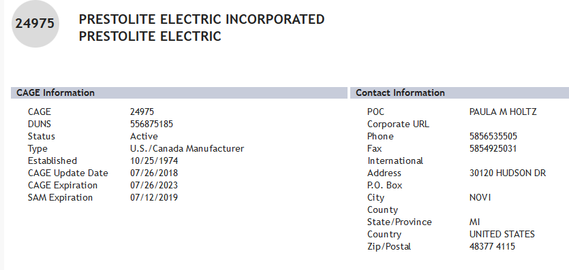

I&S and Order of Use
USS Duarte ordered 013201315 and received a BB and then ordered NIIN 012861498, a suitable substitute with an OOU of AAA…

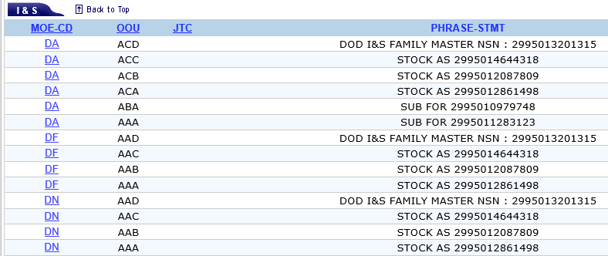
What does all this mean? Check out the below chart:

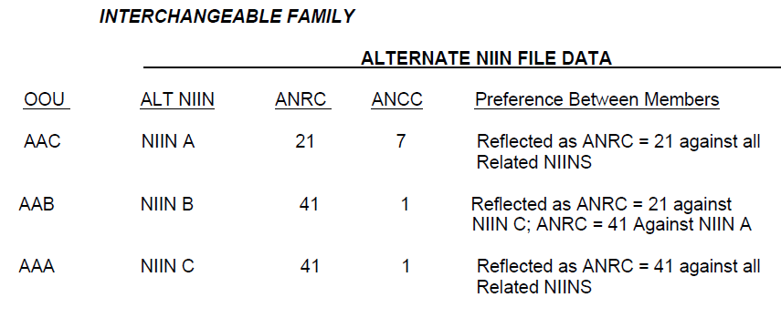

USS Duarte received some cancellations which need to be researched.

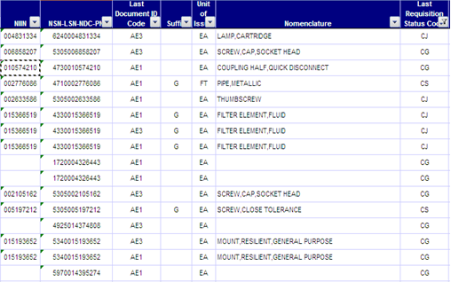

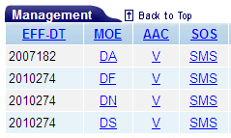
They have status codes of CJ, CG and CS. For CJ, the item is obsolete and is no longer stocked. You may want to use FIMARS (Afloat Asset Visibility) or DLA Asset Visibility to find material which may still be stock outside of DLA. You may be able to do an OSO transfer or use your purchase card and buy the part. For NIIN 004831334, WebFLIS has an Acquisition Advice Code (AAC) of V for DN (Navy). V means the NIIN is a Terminal Item. Item is in stock but no future purchases are authorized and Y isn’t stocked. For status CG, once you validate the NIIN, check for Source of Supply (SOS) and AAC. For NIIN 010574210 there is a SOS of GSA as of March of 2010. Looking at the document history, we see the requisition entering the system through NNZ.

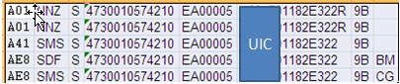

For some reason, NNZ thinks this NIIN is managed by DLA and since they are trying to pass the requisition to DLA (DOCID A41) when it is actually managed by GSA, the requisition will always be cancelled. NNZ probably has a problem loading change notice and this defect should be passed to NNZ. If you submit this requisition again, the same thing will happen. Since this is a Ship, they are not authorized to send requisitions directly to GSA but they can use their Government Purchase card to purchase this item through FED MALL or GSA Advantage or possibly out in town, based on urgency of need.

