Distribution Standard System (DSS) MRO Tracking System
The Distribution Standard System (DSS) MRO Tracking System allows the user to enter a requisition number and obtain the current status of their requisition if it was issued from a Defense Depot (DD). DSS MRO can perform single or batch queries and also has links to commercial shippers.

DSS MRO Main Menu

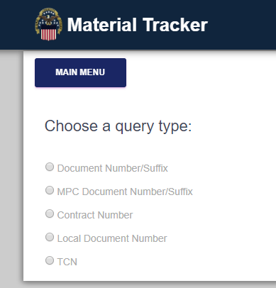

Select and enter a document number and click on Submit

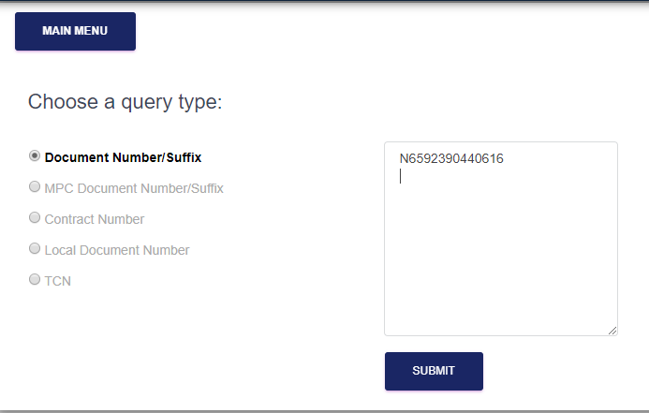

Query is returned and for greater detail, click on the magnifying glass

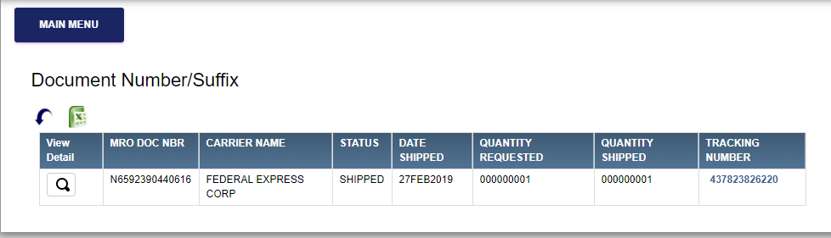

The detail window will provide data on issue quantity and shipping information. Below was shipped via FEDEX and has the FEDEX tracking number. Copy this number and go to FEDEX.com and paste the tracking number

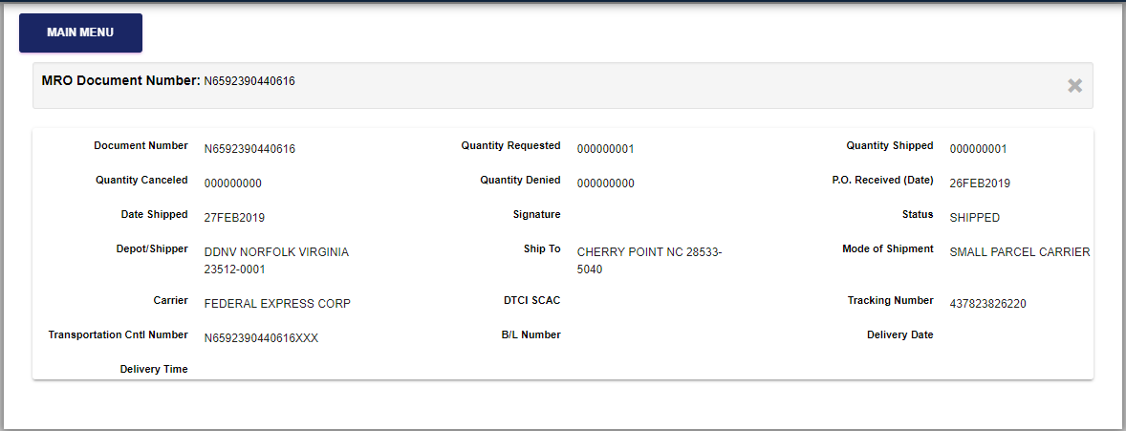

Enter the tracking number

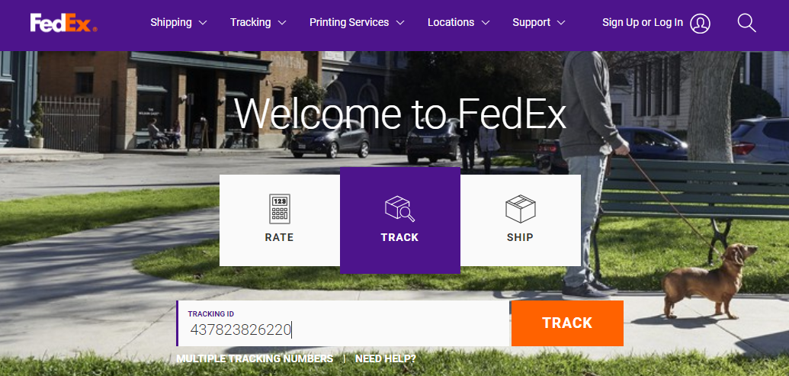

Result will show delivery information

