DLA Disposition Services

DLADS is a great way to find free parts. If you aren’t familiar with DLADS, they changed their name (used to be DRMS) and the way their web site works. You must now register with the DLA AMPS system and then request a role for Disposition Services. If you have ever visited a DRMO, it probably took you a couple of hours to walk up and down the aisles looking for material. This site will let you see what is available at all DRMOs around the world. Parts from DLADS can be used to solve backorders, cancellations and even find repairables needed for turn in or stripping for parts.

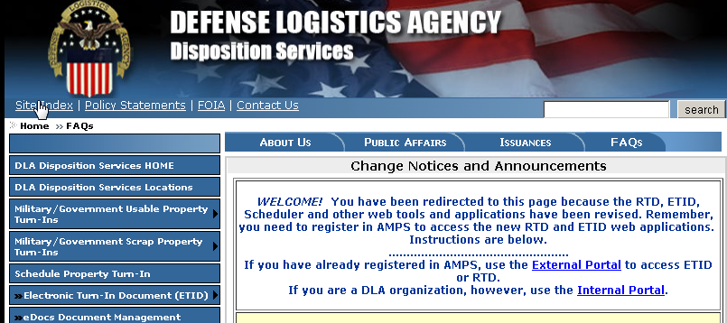

Click on the blue underlined words “External Portal”

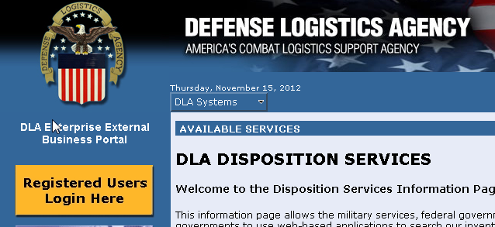

Next click on the yellow button which has “Registered Users Login Here”

You will be asked for CAC information again.

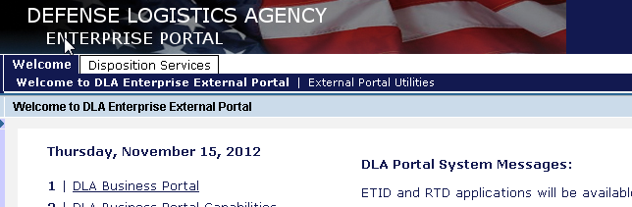

Click on the “Disposition Services” tab.

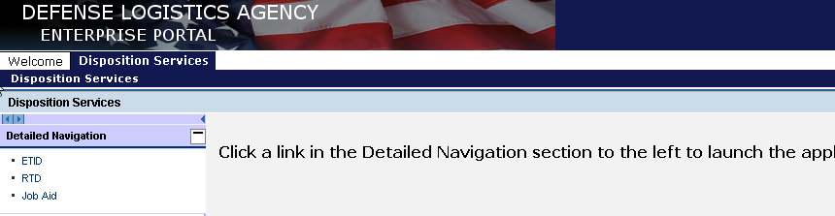

Next click on “RTD”

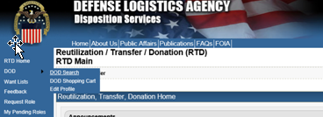

Mouse over RTD and click on DOD Search.

The below screen will come up and allow pasting up to 70,000 NIINs.

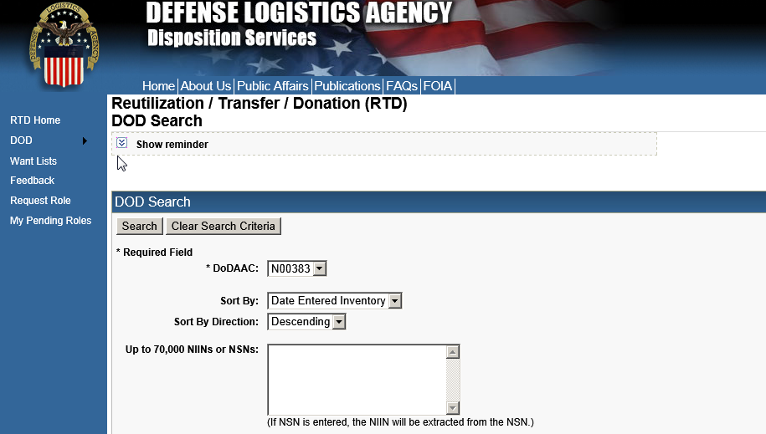

In Section A, enter your DODAAC (like N00383) in the Required DODAAC field and NIIN 009092483 NIIN or NSN window, or you can upload your file of NIINs in the next block down. Or you can use list of NIINs from a spreadsheet or text file. Copy the NIINs and paste them in the block to the right of where it says Up to 70,000 NIINs… Note the comment on screening cycle. If your need is IPG 1, you can get any material outside of normal DOD screening. Note: DoD MILSTRIP requests can only be made against items in the two DoD and FEPP cycles unless the Priority is 1-3. Select the condition code/s you are interested in. Remember you can use up to F condition assets if you are in need of a turn in for a repairable requisition.

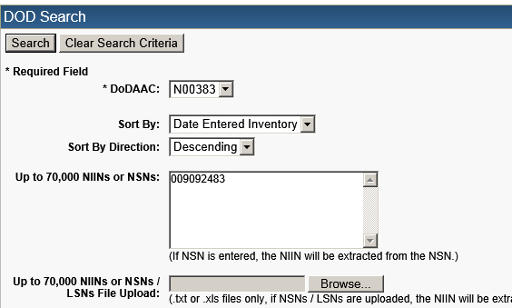
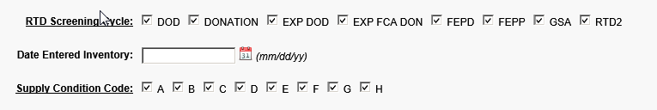

The resulting screen will return available assets.

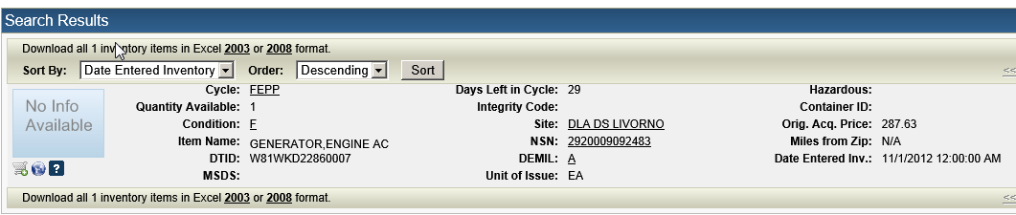

This NIIN is a repairable managed by RIC AKZ which is Army TACOM but also used by the Navy. So if you lost your turn-in, this would be an excellent place to get one. The below item is in F condition. You would normally turn in a repairable when it was in F condition. Also realize that GAO has done many audits on DLADS and a continual finding is that there are many discrepancies related to condition code. One of these may be in A condition! If you are screening large numbers of NIINs, you can download the returned data in Excel format.

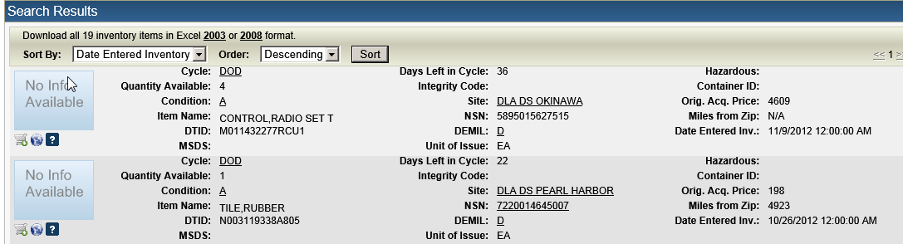

Select Excel format.

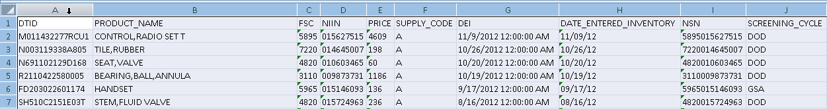

A spreadsheet will now download.

If you have a question concerning something like condition, you can click on the DRMO name and all the POC information will come up. Give them a call or email. You can also ask them to take a picture if the need exists to verify condition. This past year, I recalled for Navy use 1,000 rifle scopes which were turned in as H condition. After seeing a picture, it was clear they were new in the box A Condition… Big win for the Navy!

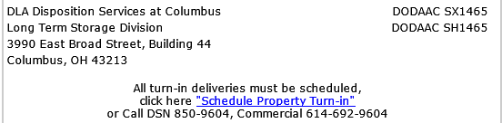

You may not be authorized to requisition material so you need to work with your supply people to get anything from DLADS. If you are authorized to order material, add material to the shopping cart by clicking on the small shopping cart icon for each item you want. Then go the shopping cart to complete the required fields and complete the process for each item and then click on the check out.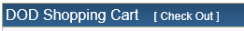

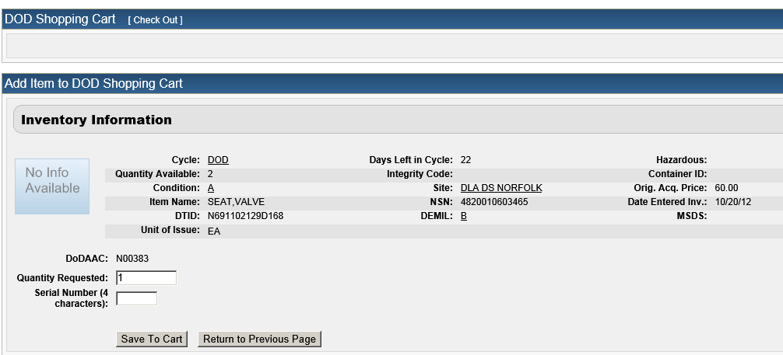

In this part of the requisitioning process, DRMS wants to know how many you want and the serial number of the requisition. The DODAAC and Julian date for the requisition number/s will be generated automatically. Insure the priority of this requisition meets your actual need.

Many people ask if this costs anything. DRMS does not charge the Services for material or shipping. Good hunting!

