HMIRS

How to use the DLA HMIRS program

If you are in the Navy and need to get some ALTRA MIL4 80W90 LIMITED SLIP NIIN 000019395, you may want to register for the NAVSUP HMCM Tool because, chances are you may be able to get it for free.
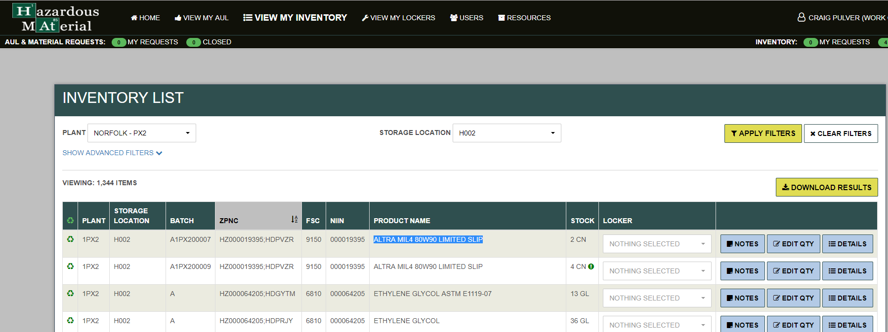
If you need to get the MSDS, HMIRS is probably the site you want to use. You must register for the DLA AMPS program first and then request a role for HMIRS. This is a painful process but well worth it since once you have access to AMPS, you can also request a role for WebFLIS and DLA Disposition Services (old DRMO).
So you now have the ALTRA MIL4 80W90 LIMITED SLIP you ordered and just as you suspected, there is no MSDS and you need to use the HMIRS program to get one. You can search for HMIRS in LogTool to get to this site and use the Quick Ref to refresh your memory on how to use it.
Once registered the below screen will be displayed.
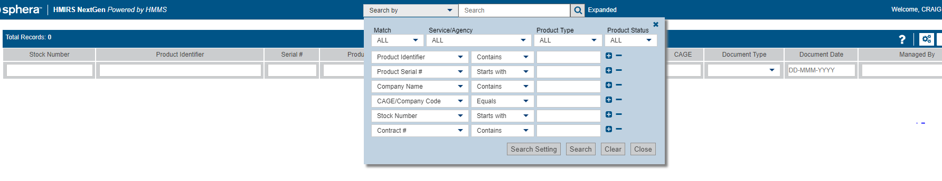

Enter NIIN 000019395
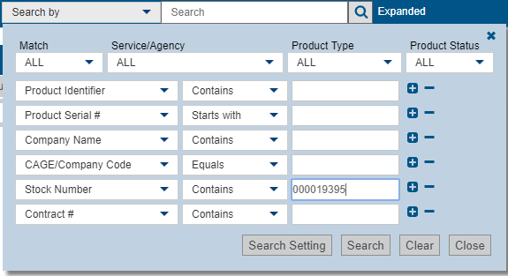
Click on Search to find what you are looking for
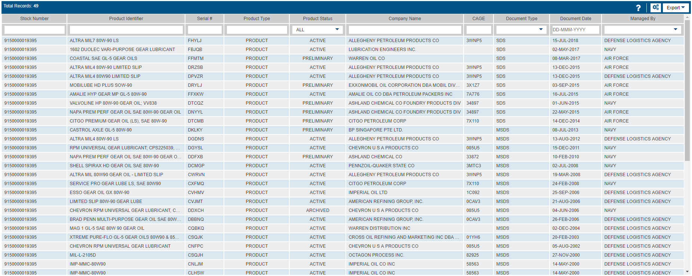

If you use multiple data elements to search, there are fewer choices
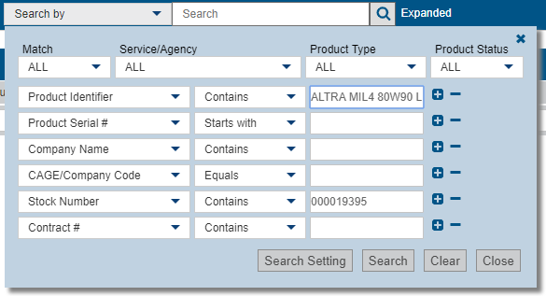
This returns the one needed
Click on the line and a detailed sheet comes up which allows downloading of the Safety Data Sheet.
