CDMD-OA Login Process using Navy Enterprise Data Center (NEDC) Citrix Site

NOTE: You must have your PKI email certificate registered in order to log into the upgraded Citrix environment. If you do not have CDMD-OA options when accessing the Navy Enterprise Data Center (NEDC) Citrix site, follow the directions on page 8. The NEDC does not allow vendor issued certificates using External Certification Authority (ECA). Contractors who have ECA certificates will not be able to access the Citrix-based CDMD-OA application in the upgraded environment.

Log into the NDE portal to use CDMD.NET, the News/Documents/Files/Training Information, or to enter an AutoSIR. (https://www.nde.navy.mil)

Open Internet Explorer and enter the NEDC link (you can copy/paste):
https://nedcchrgw.dc3n.navy.mil/

Do not maximize your IE screen. During the log-in process, some screens open up behind IE and a maximized screen adds more steps to getting to those screens.

If you get a message "You are not allowed to login. Please contact your administrator.", close the web browser and try again. It is not common to get this message, however it does occasionally appear.

Select E-MAIL cert when prompted.

Click OK to agree with the U.S. Government (USG) information system banner page.

Follow the next set of screens to complete the log-in.

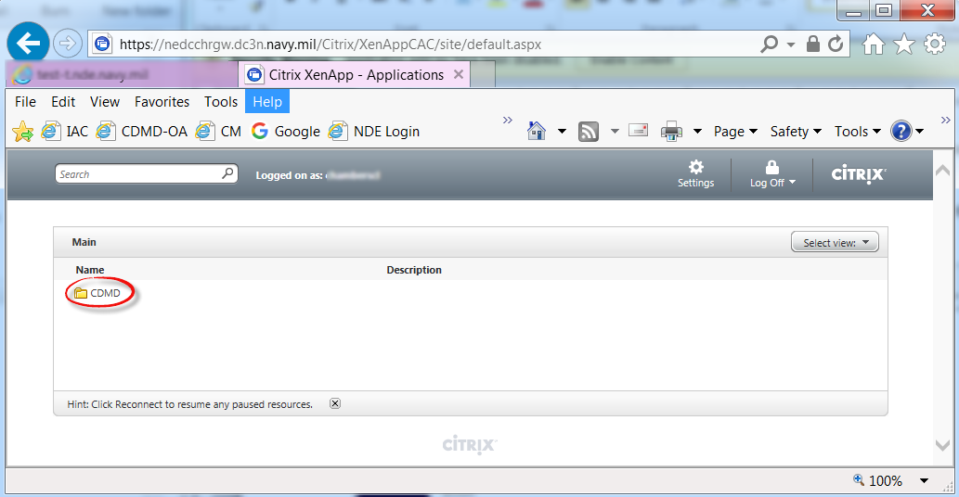
Click CDMD

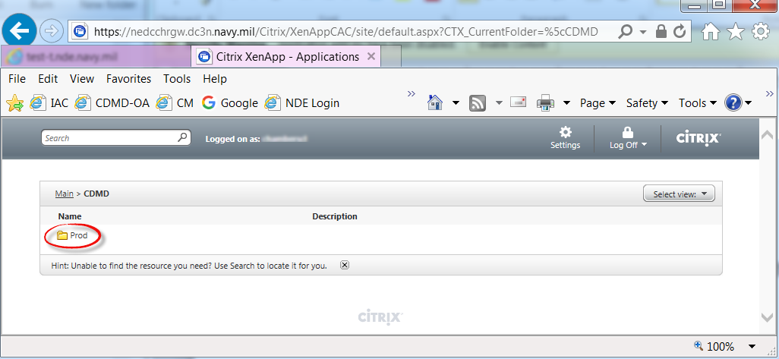
Select Prod

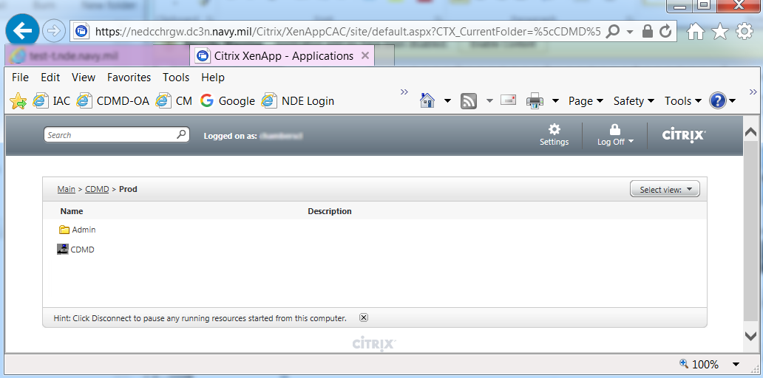

For this example, CDMD is being selected. If you are a user on the Newport server, you will have selections for Carrier-Submarine.

Select CDMD (or Carrier-Submarine if applicable).

The Windows Security screen will likely open behind other screens. If it seems like nothing is happening after selecting the site, minimize other screens.

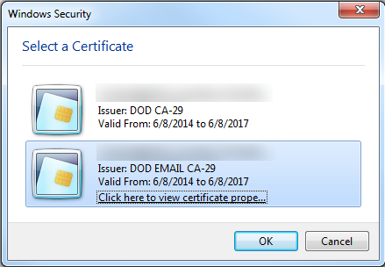
Select e-mail cert

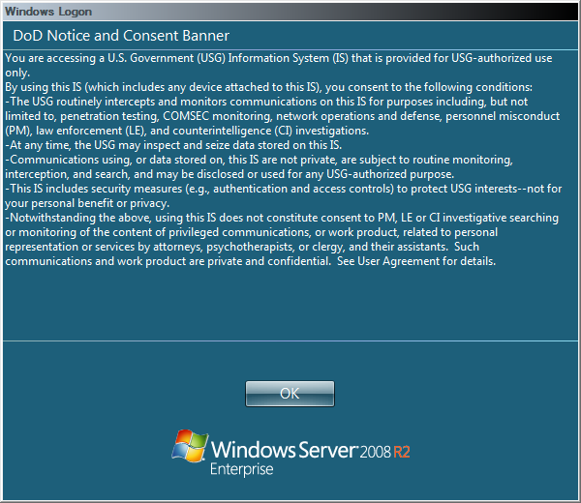
Click OK
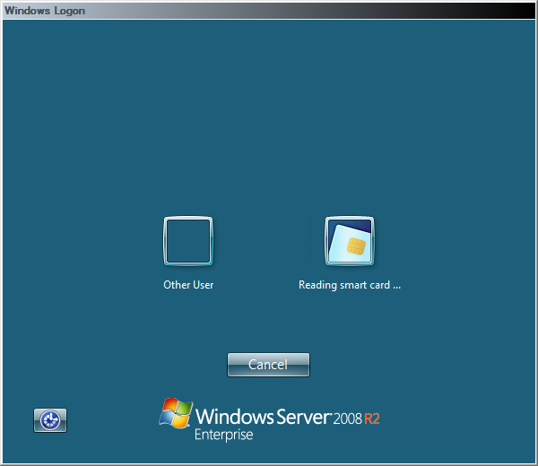
This screen takes a little while to load. Wait for it to read your card.
Once your certificate is displayed, you only have about 5 seconds to select it.

HINT: Keep your mouse in motion while waiting for the certificate to display. You can just move it back and forth. This will prevent the screen from timing out.

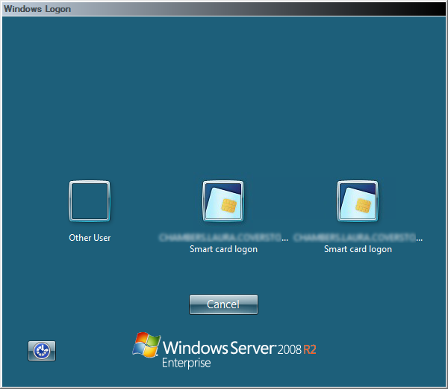
The information on the screen will look the same for both icons. You need to select the e-mail certificate. Unfortunately, the icons do not distinguish which certificate is the e-mail. You can try either icon. If you get an error message after entering your PIN, then choose the other icon the next time around.

HINT: Select the icon quickly since the screen will timeout in about 5 seconds
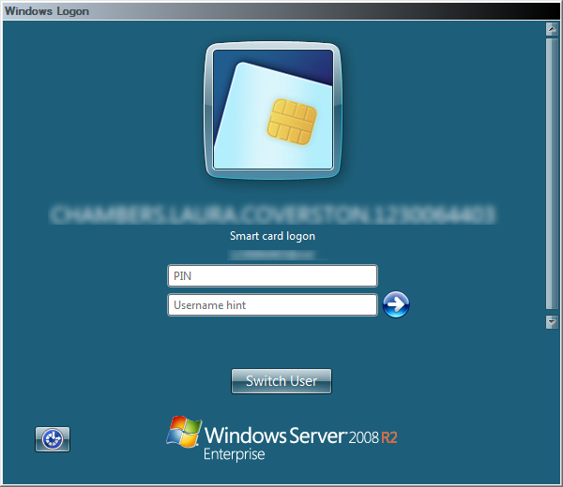
Enter PIN.
Hint: If you cannot type in the box, click the small box on left corner. Another screen will pop-up. Click Cancel on the pop-up screen. Now you can type in the PIN.

Here is the error message you will get if the wrong certificate was selected:
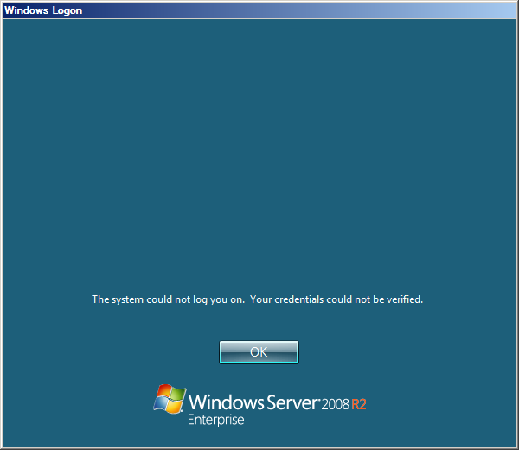
Click OK and the Windows Logon screen will close. Select CDMD again on the NEDC Citrix screen to start again.

If everything has went well with the Windows Logon,

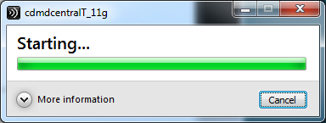

When the Starting processes have completed, the Citrix CDMD-OA login screen will be opened.

Central is the first database in the list and will be the default. If you have access to other databases, you can change the selection from the database drop down list. Change the database BEFORE entering the UIC/User ID/Password. Here is an example (the Newport database list will be different):

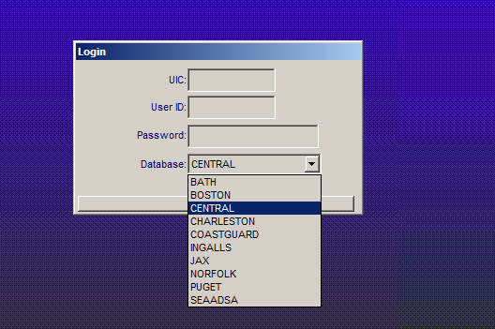

- Select Database from dropdown list if you are logging into something other than Central
- Enter the UIC portion of your user-id (example N12345)
- Enter the User ID (the portion after the UIC)
- Enter the Password

When the log-in is successful, you will get a verification:

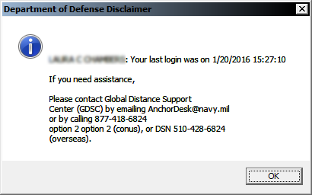

After clicking OK, the CDMD-OA application will load.

NOTE: If you get the following error, click “Exit the Program”. Select the CDMD icon again and re-enter log-in information. This error is random and it can take a few tries before the log-in succeeds. We are aware of the problem and a solution is being worked on.

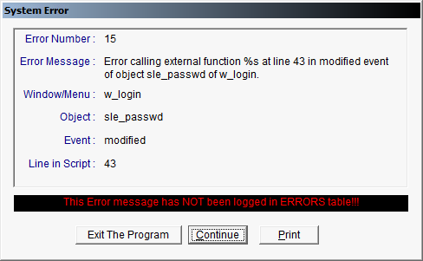

The NEDC Citrix screen will time-out after 15 minutes. This does not effect your connection to CDMD-OA. If the following message is displayed, you can close the browser window and continue working in CDMD-OA.

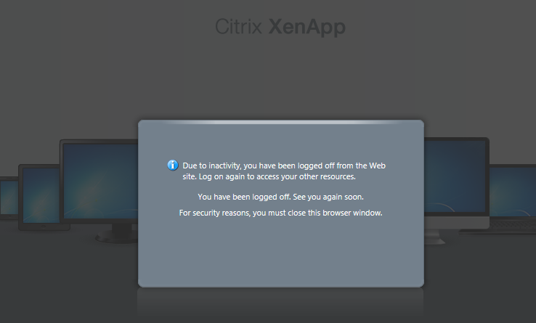
CDMD-OA Citrix Application PKI Registration

The CDMD-OA servers and Citrix environment are being upgraded and moved to a new domain. Part of the process requires that every user register their PKI certificate through the NEDC Data Center before the live cutover to the upgraded environment. Please do this registration as soon as possible. Failure to register your PKI before live cutover will delay your access to the systems after cutover.

Step 1: Open Internet Explorer and go the following Link - https://nslcreg.dc3n.navy.mil/

Step 2: The digital certificate selection box should appear.

- Select your EMAIL certificate

Email Certificate

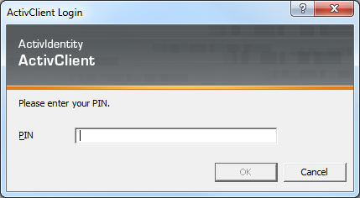

Step 3: On the client registration screen, select the CDMD-OA box.
NOTE: If you are a contractor please check the selection box for contractor.

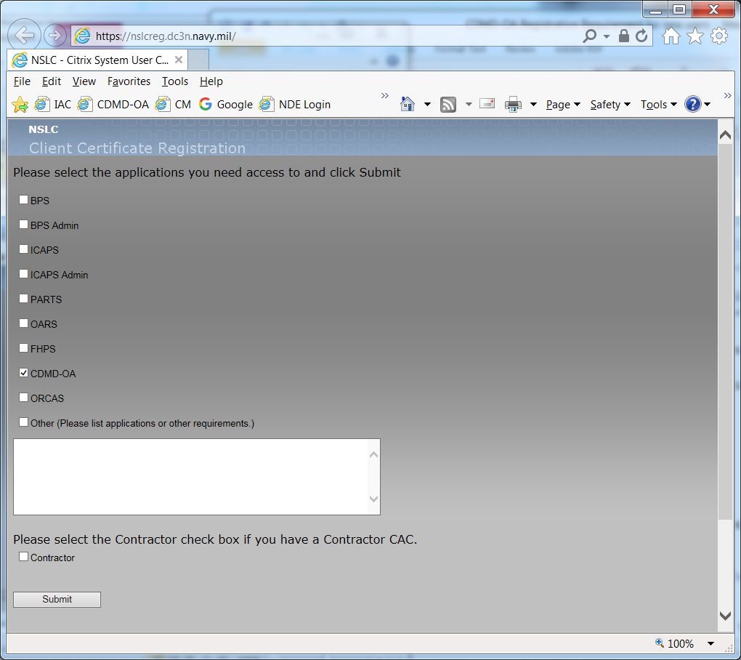

Step 4: Click Submit. A confirmation screen will display.

Step 4a: If you get a message that you are already registered, send an email to cdmdoahelpdesk@navy.mil. Copy and paste the following into the e-mail:

“My CDMD-OA User-id is: [fill in user-id]. During the Active Directory registration I received the message that I am already registered.”

NOTE: If you get a proxy error, please try again. It may take a couple of attempts. Your error could be due to server capacity and we ask that you try again during slower times (such as late afternoon, Friday afternoon, etc). We are continuing to troubleshoot for other causes of this issue. If you are a current user of one of the other listed systems, include the name of the system in the e-mail and we will add CDMD-OA to your profile.

Step 5: (not applicable if 4a applies) An email will be sent to the Admin and an email will be sent to you stating that the request was submitted.

Email you should receive when you submit your request

From: NSLC DC3N Registration Administrator
Sent: Friday, January 15, 2016 1:55 PM
To: John Doe
Subject: Your NSLCPORTAL DC3N Citrix account has been created!

Your NSLCPORTAL DC3N Citrix account has been created!
Once your account has been approved you will receive an email from the
administrator.

Name: John Doe
Email: john.doe@navy.mil

Certificate Information:
Issuer: C=US, O=U.S. Government, OU=DoD, OU=PKI, CN=DOD EMAIL CA-29
Subject: C=US, O=U.S. Government, OU=DoD, OU=PKI, OU=USN,
CN=DOE.JOHN.1122334455

Client certificate information has been received and logged successfully

Accounts Requested:
Other

Other Information:
CDMD-OA

End of E-mail

Step 6: No further steps are needed at this time. You will be notified when the new log-in process is ready for use.

