NAVSUP INFORM21 FIMARS

Access to FIMARS (Afloat Asset Visibility) is through the NAVSUP INFORM21 system.
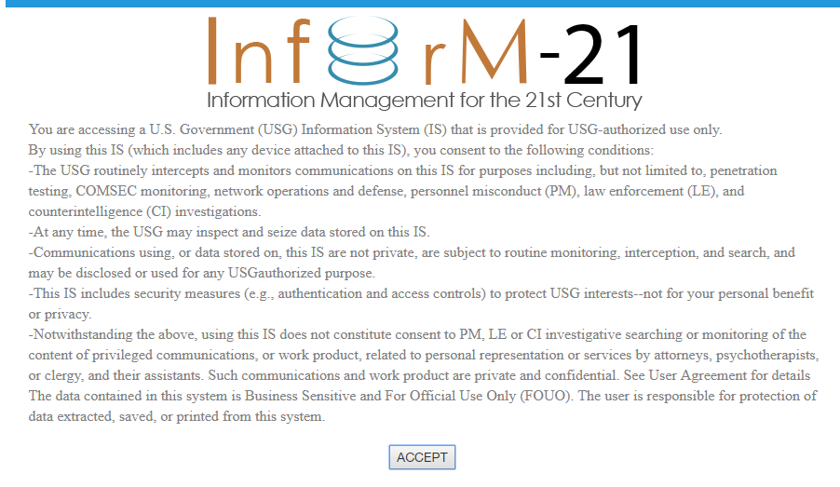
Click on Accept and a listing of programs you have registered for are listed.

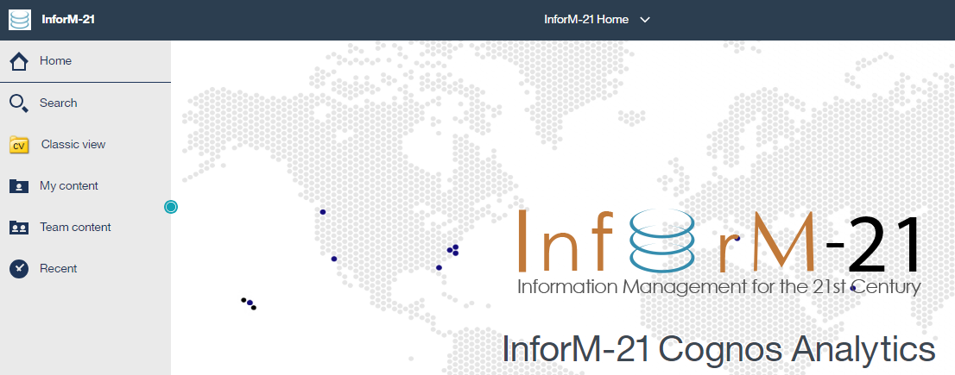

Next click on Classic view to see the programs you are registered for. The 2 programs you may want to register for are ACWT (Birdtrack) and FIMARS. These will require a separate SAAR-N.

Click on FIMARS and select Master Stock Status Location Report.

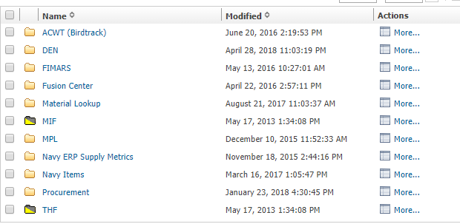

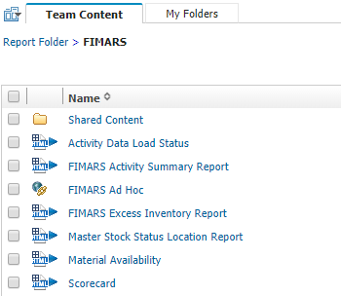

Copy and paste your NIINs, select what activities to search, ATCs and if you want to display NIINs with 0 balances.

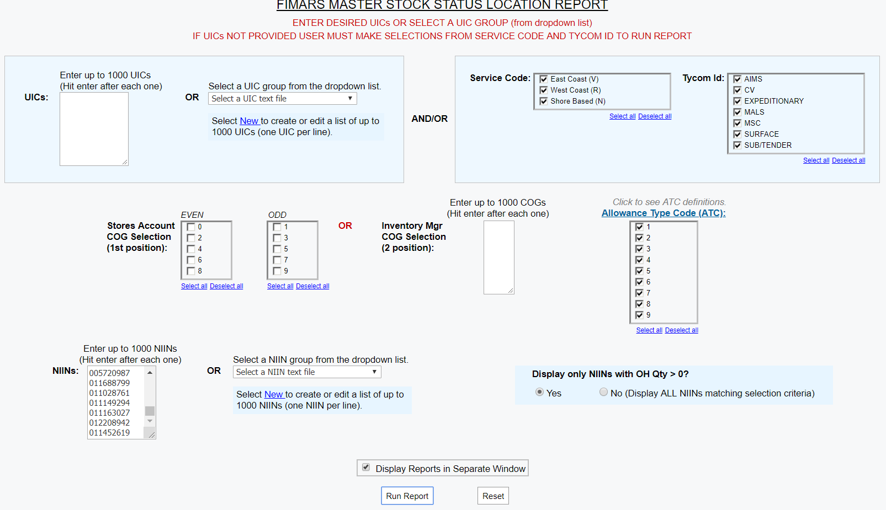
Results will come up in another browser window.
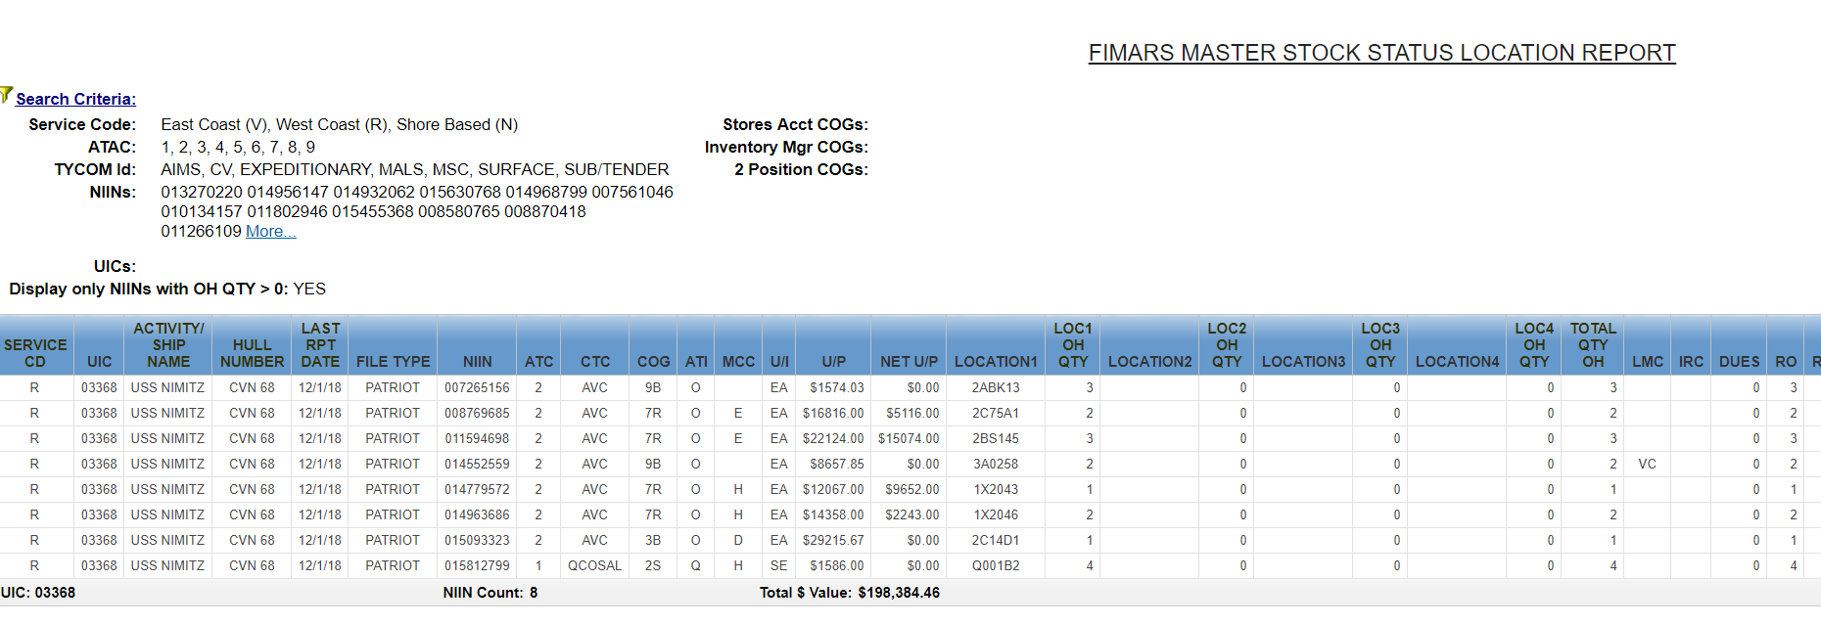

Once the data is returned, if you want to see the data in spreadsheet format, follow the links to do that.
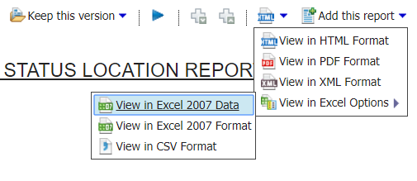
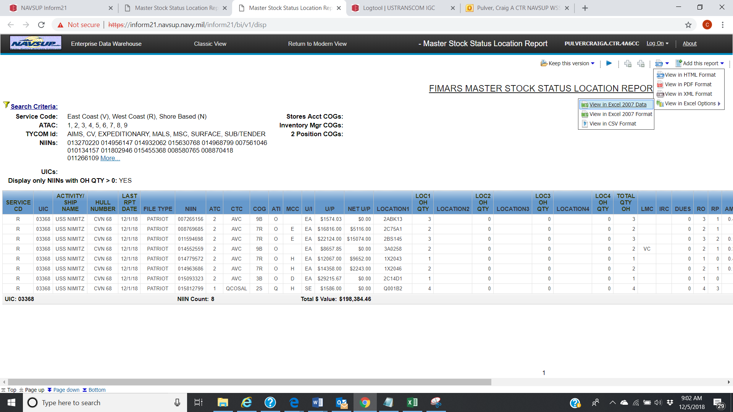
Another browser page will open and download the file.
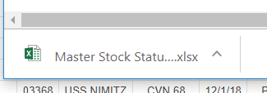
Click on the Excel file to open it.
