MOF Data Cleansing
Data from the MOF download needs to be cleaned up. Some of the data is ok but other data needs to be converted.
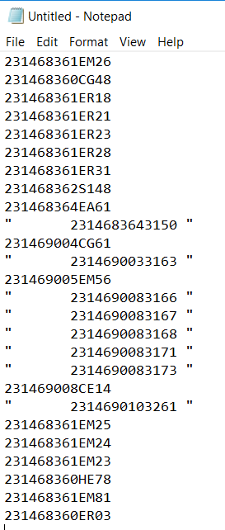
Copy the Doc Number column and paste it into Notepad
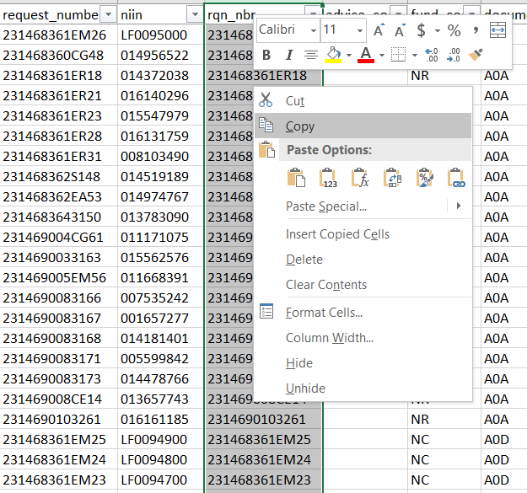
Once the data is pasted in Notepad, copy one of the spaces.
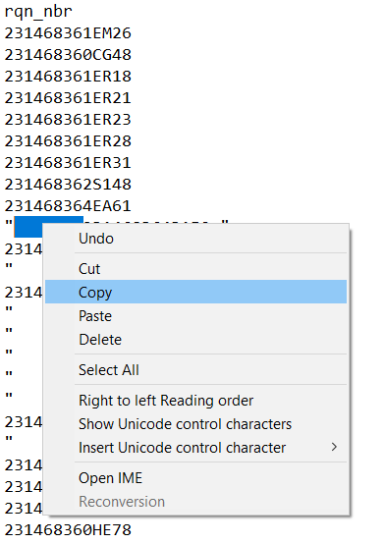
Next, go to Replace
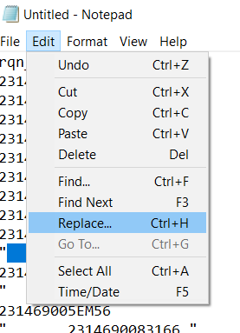

Next Replace All the space with nothing
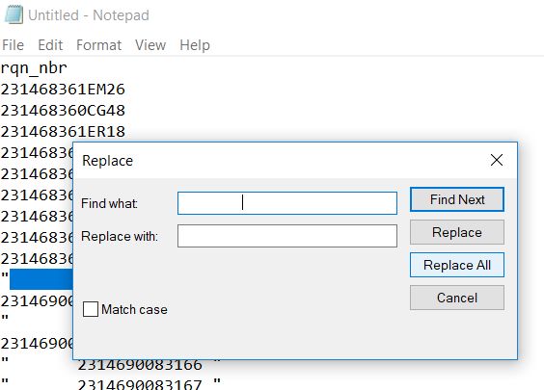

Next, replace all of the quotes with nothing
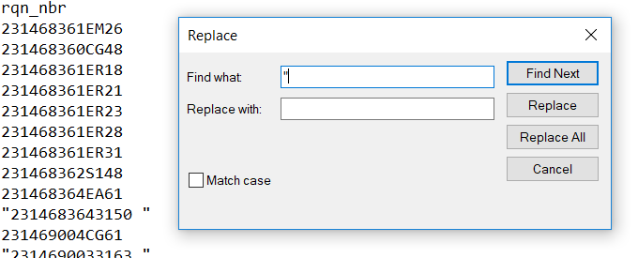

Finally, replace all trailing spaces with nothing
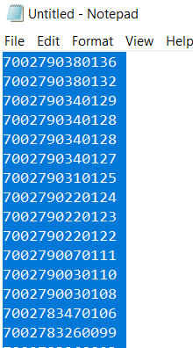

In the end, the data has been cleaned and should be copied and pasted in the MOF spreadsheet
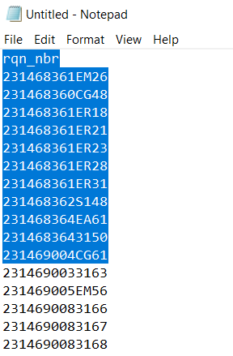
After the data is pasted, you will notice some of the data is not real. To fix this do text to column in Excel and designate the data as text.
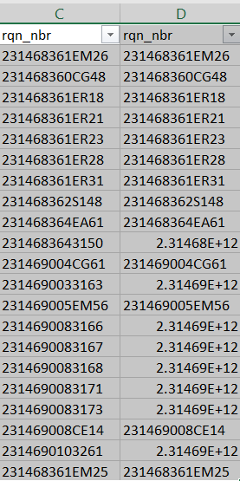
Highlight the column and under Data select Text to Column, select fixed width and click on Next
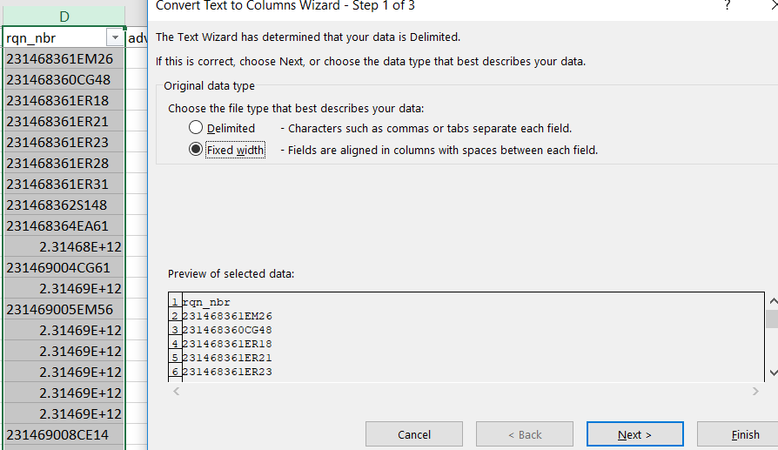
Put a line after the requisition number and click on next
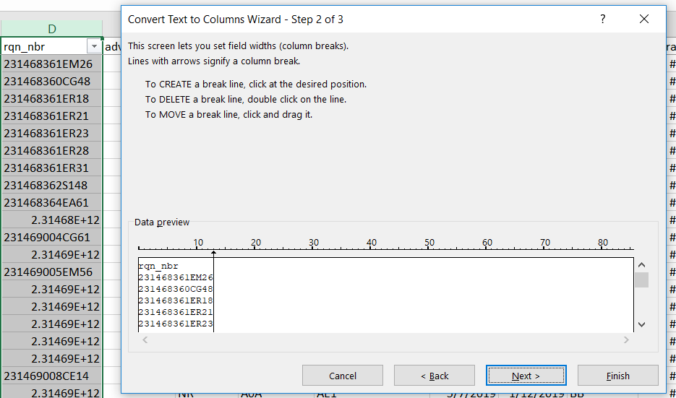
Select Text and click on Finish
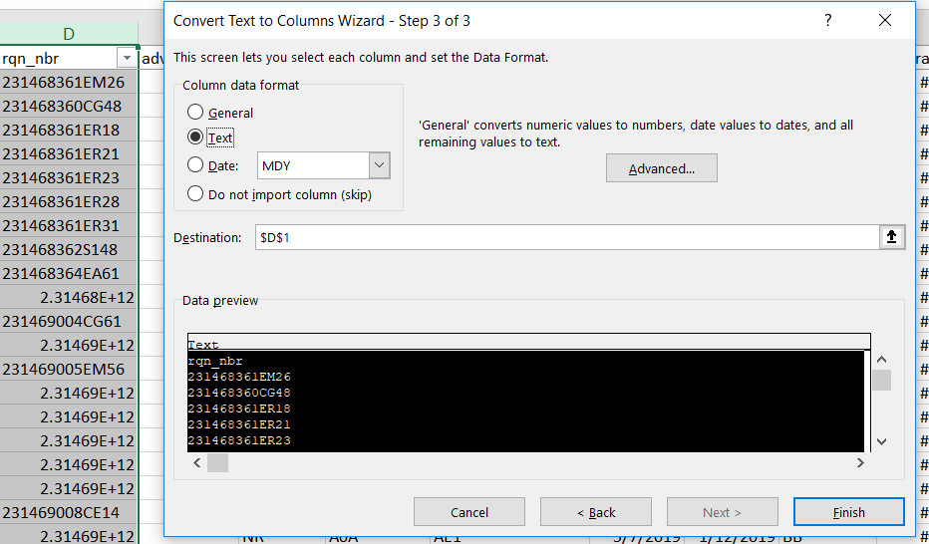
Your data is now fixed
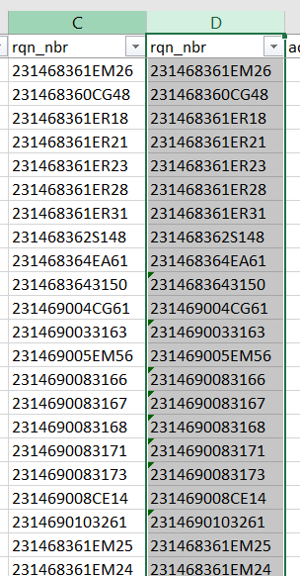
The same fix should be done with the NIIN column. Make sure you format the column as text or you will lead the leading zeros

